Group Members:

KEERTHi Reddiwandla

Nishchay Mishra

Parth Gupta

Priya Matta

PROJECT 1

FIN 6392- Financial Technology and Blockchain

Contents

REPORT SUMMARY 2

PROFILE INFORMATION 3

TECHNICAL ANALYSIS 3

FINANCIAL ANALYSIS 5

FACTOR MODEL 6

SENTIMENT ANALYSIS 7

PORTFOLIO OPTIMIZATION 10

PORTFOLIO BACKTESTING 11

# REPORT SUMMARY

This report is designed construct a big data alpha model for three stocks IBM, iROBOT and NETFLIX. For each stock we retrieve technical indicators and fundamental indicators from 2016-01-01 to 2019-09-01. After careful analysis of the indicators we create a factor model using all the indicators. The results of the panel regression indicate that the coefficient of RSI14 is the only significant indicators for the stocks. To analyze the sentiments impact on the stock returns we extract various sentiments from the reddit and using regression analysis test the impact of the sentiments on stock price.

For Portfolio analysis using R we create an optimum portfolio and to test the results we back test the returns based on the weights from the optimized portfolio. The results indicate that the optimum portfolio has better returns compared with equally weighted portfolio and S&P 500 index for the period of study.

# PROFILE INFORMATION

**IBM Corporation** provides information technology (IT) products and services worldwide. The company's Global Technology Services segment provides IT infrastructure and business process services and technology support. Its Global Business Services segment offers consulting solutions for strategy and transformation and application management, maintenance, and support services. The company's Software segment offers middleware and operating systems software. Its Systems and Technology segment provides computing power and storage solutions; and semiconductor technology, products, and packaging solutions. The company's Global Financing segment provides lease and loan financing to end users; commercial financing to dealers and remarketers of IT products; and remanufacturing and remarketing services for equipment.

**iRobot Corporation** is a consumer robot company, which is engaged in designing and building robots. The Company's portfolio of solutions features various technologies for the connected home and various concepts in mapping, navigation, mobility and artificial intelligence. The Company sells various products that are designed for use at home. Its consumer products focus on both indoor and outdoor cleaning applications. The company also provides defense and security products.

**Netflix, Inc.** provides Internet television network service that enables subscribers to stream TV shows and movies directly on TVs, computers, and mobile devices in the United States and internationally. The company operates in three segments: Domestic Streaming, International Streaming, and Domestic DVD.

# TECHNICAL ANALYSIS

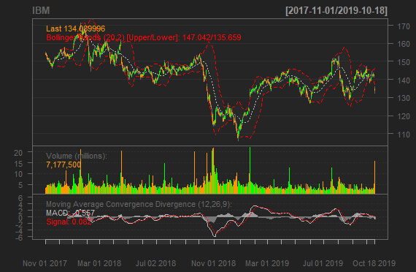We found 2 important **support and resistance areas**.

* A support zone ranging from 130 to 131.50.
* A support zone ranging from 116 to 120.
* A resistance zone ranging from 138 to 142.
* A resistance zone ranging from 148 to 152.

These zones are visible in multiple time frames.

**BB Band**

Chart shows a smaller W-Bottom in early September. The stock surged with expanding volume in late September. But soon the price tags the lower band in mid-October which was a warning sign.

**RSI (14 days)**: The value of 37.19784 generates a neutral action

**MACD**: Using the ideal MACD with (12,26,9) a sell signal is generated the MACD line falls below the signal line and the value of -0.557

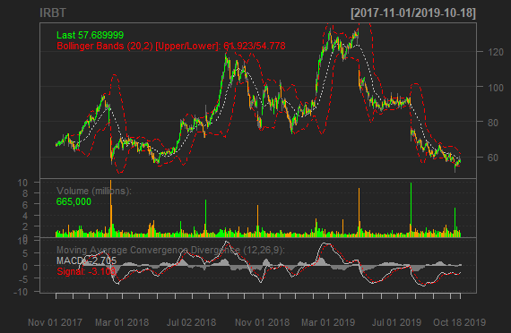IROBOT

We found 2 important **support and resistance** areas.

* A support zone ranging from 75 to 78.
* A support zone ranging from 58 to 60.
* A resistance zone ranging from 100 and 102.

These zones are visible in multiple time frames. The price below the support level of 58 is an indicative of future bearish trend.

**BB Band**

Chart shows a smaller M-Top between march and may. Since then there is a downward trend with expanding volume till early September. But soon the price tags the lower band in mid-October which was a warning sign.

**RSI (14 days):** The value of 43 generates a neutral action

**MACD:** Using the ideal MACD with (12,26,9) a strong sell signal is generated the MACD value of -2.705

**NETFLIX**

We found 2 important **support and resistance** areas.

* A support zone ranging from 260 to 265.
* A resistance zone ranging from 286 to 289.

These zones are visible in multiple time frames. The price above the support level of 265 is an indicative of future bullish trend.

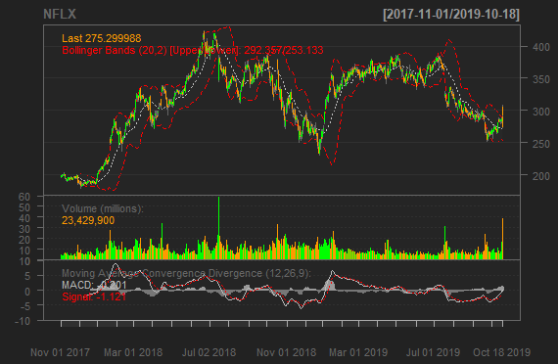**BB Band**

Chart shows increasing width of the bands which reflects increasing volatility. Since there is an upward trend with expanding volume it can be a strong bullish signal

**RSI (14 days):** The value of 45.909 generates a neutral action

**MACD:** Using the ideal MACD with () generates a buy signal with a bullish crossover occurs as the MACD turns up and crosses above the signal line.

# FINANCIAL ANALYSIS

**IBM Corp’s** revenue and net income declined from 2016 to 2017 but then increased from 2017 to 2018 not reaching 2016 level. A declining EPS trend which is a signal to investors that a company is in trouble, which can lead to a decline in the stock price.

**iRobot** During the past 4 years, the average EPS and EBITDA CAGR was 5.6% and 7% respectively. The management team that has a proven track record of generating superior earnings growth over the long term.

**Netflix Inc** achieved increase in profitability, due to increase in demand (internationally) and cost control. During the past 4 years, the Net Income and Revenue CAGR was 59.6% and 16% respectively. Although the EPS declined from 2017 to 2018 but it is stable for 2019, not reaching 2016 level . Even with new competitor entrance there is a lot of room for growth within the industry.

# FACTOR MODEL

There are two main categories of factors used for the analysis: **technical and fundamental**. Statistical technique used to identify significant factors is Panel Regression. Below is the regression output:

* The Model R2 is near to 1.3% which is very low.
* Model states that the only rsi14 is the only significant variable at 1% significance level.
* P-statistics is less than 0.05, F-statistics is significantly high.

|  |
| --- |
| ######################### Performance Analytics ############################  Oneway (individual) effect Within Model  Call:  plm(formula = Return_lead ~ sma20 + ema14 + dn + mavg + up + pctB + rsi14 + macd + signal + EPS + Revenue + EBITDA + Net_Income + Income_Tax, data = stocks, model = "within", index = c("ticker", "timestamp"))  Balanced Panel: n = 3, T = 908, N = 2724  Residuals:  Min. 1st Qu. Median 3rd Qu. Max.  -0.32355396 -0.00921094 0.00020257 0.00973635 0.21087642  Coefficients: (2 dropped because of singularities)  Estimate Std. Error t-value Pr(>|t|)  sma20 -7.3367e-05 2.4961e-04 -0.2939 0.768834  ema14 -6.6538e-05 2.3518e-04 -0.2829 0.777252  dn 3.0854e-05 6.6292e-05 0.4654 0.641670  pctB 2.2652e-03 1.9221e-03 1.1785 0.238701  rsi14 -1.2338e-04 4.7636e-05 -2.5901 0.009646 **  macd -2.3100e-04 4.0460e-04 -0.5709 0.568096  signal 3.5567e-04 3.4312e-04 1.0366 0.300019  EPS -1.5453e-05 2.6823e-05 -0.5761 0.564589  Revenue 6.5815e-03 9.2454e-03 0.7119 0.476607  EBITDA -4.5207e-03 1.2213e-02 -0.3701 0.711301  Net_Income -2.6506e-03 1.6546e-02 -0.1602 0.872744  Income_Tax -2.8771e-03 1.9217e-02 -0.1497 0.880998  ---  Signif. codes: 0 ‘***’ 0.001 ‘**’ 0.01 ‘*’ 0.05 ‘.’ 0.1 ‘ ’ 1  Total Sum of Squares: 1.5318 Residual Sum of Squares: 1.5112  R-Squared: 0.013439 Adj. R-Squared: 0.0083409  F-statistic: 3.07527 on 12 and 2709 DF, p-value: 0.00024783 |
|  |
|  |

# SENTIMENT ANALYSIS

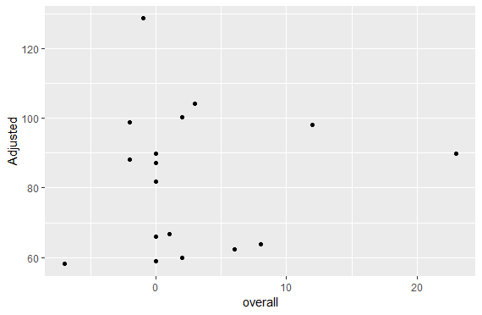**IRBT**

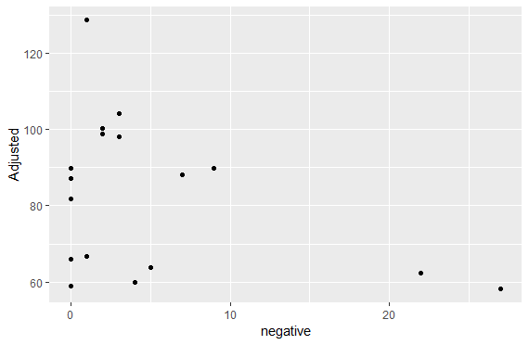 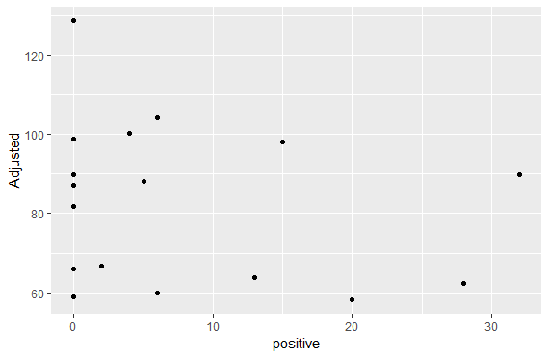

> cor(new$Close, new$overall)

[1] 0.09447147

> cor(new$Close, new$positive)

[1] -0.2285886

> cor(new$Close, new$negative)

[1] -0.3840408

The Regression model has a very high p value and results indicate that the sentiment coefficient is

insignificant

> # estimating beta coefficients for future prediction

Call:

lm(formula = Close ~ overall, data = new)

Coefficients:

Estimate Std. Error t value Pr(>|t|)

(Intercept) 81.7726 5.4379 15.038 1.87e-10 ***

overall 0.2828 0.7695 0.368 0.718

---

Signif. codes: 0 ‘***’ 0.001 ‘**’ 0.01 ‘*’ 0.05 ‘.’ 0.1 ‘ ’ 1

Residual standard error: 20.79 on 15 degrees of freedom

Multiple R-squared: 0.008925, Adjusted R-squared: -0.05715

F-statistic: 0.1351 on 1 and 15 DF, p-value: 0.7184

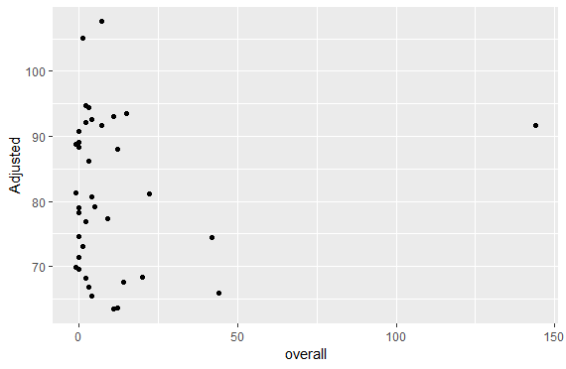**IBM**

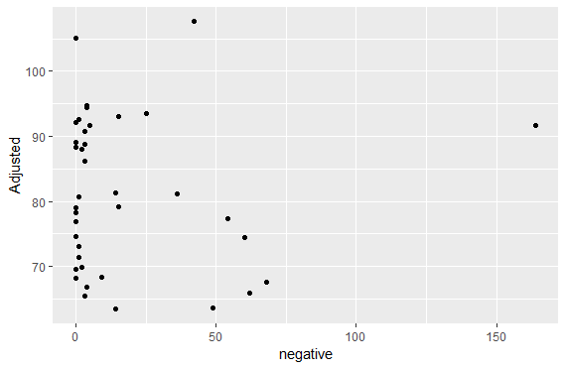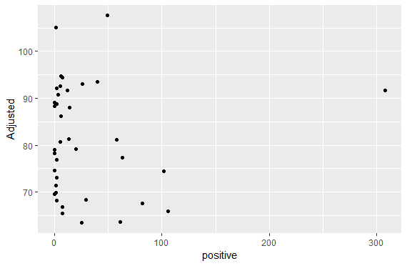

> cor(new$Close, new$overall)

[1] 0.03352712

> cor(new$Close, new$positive)

[1] 0.003049615

> cor(new$Close, new$negative)

[1] -0.02061539

The Regression model has a very high p value and results indicate that the sentiment coefficient is

insignificant

> # estimating beta coefficients for future prediction

Call:

lm(formula = Close ~ overall, data = new)

Residuals:

Min 1Q Median 3Q Max

-17.757 -10.756 -1.083 9.487 26.537

Coefficients:

Estimate Std. Error t value Pr(>|t|)

(Intercept) 81.00017 2.11031 38.383 <2e-16 ***

overall 0.01606 0.07981 0.201 0.842

---

Signif. codes: 0 ‘***’ 0.001 ‘**’ 0.01 ‘*’ 0.05 ‘.’ 0.1 ‘ ’ 1

Residual standard error: 11.92 on 36 degrees of freedom

Multiple R-squared: 0.001124, Adjusted R-squared: -0.02662

F-statistic: 0.04051 on 1 and 36 DF, p-value: 0.8416

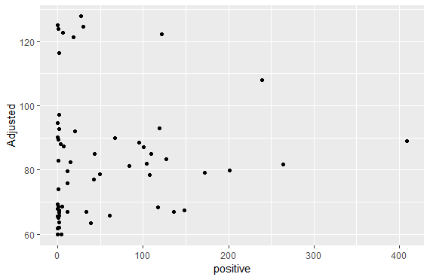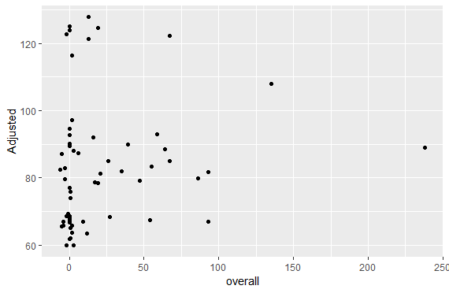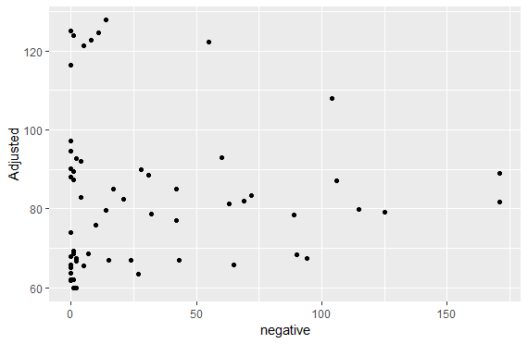**NTFL**

> cor(new$Close, new$overall)

[1] 0.1400561

> cor(new$Close, new$positive)

[1] 0.07315183

> cor(new$Close, new$negative)

[1] 0.0003278998

The Regression model has a very high p value and results indicate that the sentiment coefficient is

insignificant

> # estimating beta coefficients for future prediction

> fit <- lm(Close ~ overall, data = new)

Call:

lm(formula = Close ~ overall, data = new)

Residuals:

Min 1Q Median 3Q Max

-22.229 -15.266 -4.400 7.228 45.008

Coefficients:

Estimate Std. Error t value Pr(>|t|)

(Intercept) 81.98615 2.74304 29.889 <2e-16 ***

overall 0.06433 0.05921 1.087 0.282

---

Signif. codes: 0 ‘***’ 0.001 ‘**’ 0.01 ‘*’ 0.05 ‘.’ 0.1 ‘ ’ 1

Residual standard error: 18.96 on 59 degrees of freedom

Multiple R-squared: 0.01962, Adjusted R-squared: 0.002999

F-statistic: 1.18 on 1 and 59 DF, p-value: 0.2817

# PORTFOLIO OPTIMIZATION

To determine an optimal portfolio using the three stocks we applied a simple **mean-variance optimization** in R with the Portfolio Analytics package. The Specifications are:

Portfolio Analytics Portfolio Specification

**************************************************

Number of assets: 3

Asset Names

[1] "IBM.Close" "IRBT.Close" "NFLX.Close"

Constraints

Enabled constraint types

- weight_sum

# The weight sum is equal to 1

Objectives:

Enabled objective names

- mean #Maximize

- StdDev #Minimize

The results are as follows: As per the ROI method the portfolio comprises of **buying 93.8% of NFLX** **19.3% of IRBT and shorting 13.20 % of IBM stocks**. The **mean return is 0.1127% and variance of 0.064%**

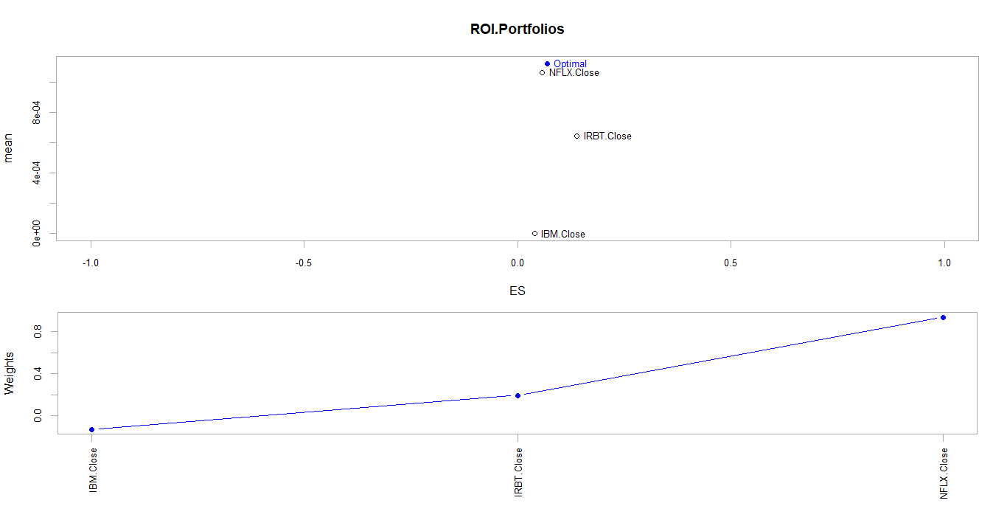

Portfolio Analytics

Optimization

***********************************

Optimal Weights:

IBM.Close IRBT.Close NFLX.Close

-0.1320 0.1932 0.9389

Objective Measure:

mean

0.001127

StdDev

0.02546

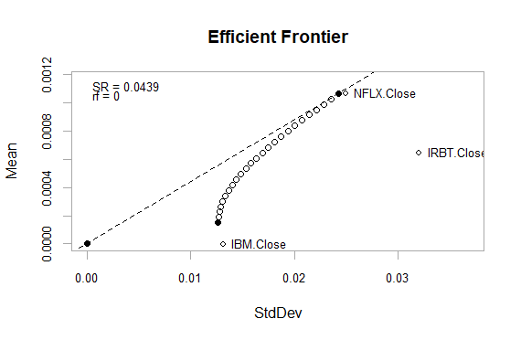**The efficient frontier** is the set of optimal portfolios that offer the highest expected return for a defined level of risk or the lowest risk for a given level

Of expected return.  It is plotted is

based on the trace information (sets of portfolios tested by the solver at each

iteration) in objects created by

optimize.portfolio.

# PORTFOLIO BACKTESTING

In this section we will be performing a backtest on our portfolio optimization with native functions in the PortfolioAnalytics package within R. Using Return.Portfolio function we calculated returns for an equally weighted portfolio (Benchmark Portfolio) for all the three stocks for better comparison. Using S&P 500 for index benchmark, below is the chart displaying the performance of the optimal portfolio (in black) compared to the benchmark/equally weighted portfolio (in red) and S&P 500 ( in green)

